Acknowledgment
This document builds upon a foundational version shared by Sajib Jahan, whose mentorship and initial work provided a valuable starting point. While refinements and corrections have been made for clarity and accuracy, his contribution and guidance remain deeply appreciated.

System Design Document (SDD)

Project Name: LaraGuard Prepared by: Arif Hossen Date: May 16, 2025

Courtesy - Inspired by: Sajib Jahan Reference doc: SDD

Date | version | Prepared by | Checked by
16/05/2025 | 1.0.0 | Arif Hossen

System Overview
LaraGuard will have the following core components:
- REST API for managing realms, users, clients, roles, and authentication.
- Admin Panel for internal user and realm management.
- Authentication/Authorization Module using OAuth2, OpenID Connect, and JWT for token-based authentication.
- Database for persistent storage of realms, users, roles, and clients.
- Token Service for OAuth2/OIDC-based login and access control.

Key Goals
- High Performance: The system should be capable of handling a high load, with the ability to support up to 100,000 concurrent sessions per realm.
- Extensibility: A modular architecture to support future integrations like external identity providers, MFA, and audit logs.
- Ease of Deployment: A simple deployment model using Docker and Kubernetes.

2. System Architecture Diagram
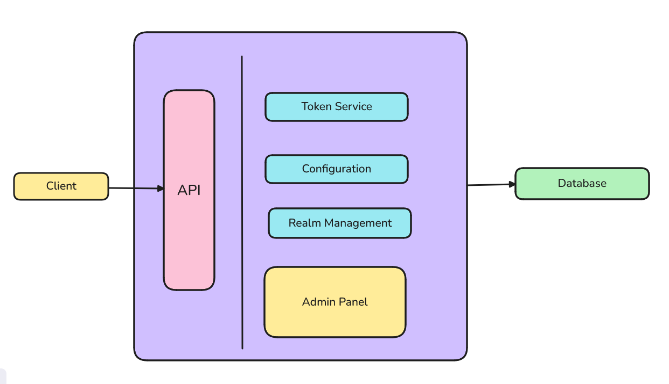
Client: Any backend machine, public frontend, mobile, or device requesting IAM service
API: API endpoints that allow clients to communicate with LaraGuard
Admin Panel: Web-based view directly built in LaraGuard core for managing realms & configurations
Token service: A Service that facilitates token generation

3. Component Breakdown

3.1 REST API Service
- Handles external communication via REST.
- Provides endpoints for managing realms, users, roles, and clients.
- Implements OAuth2/OIDC token issuance.
- Built using Go with the Gin framework.

3.2 Admin Panel
- Internal UI for administrators.
- Uses server-side rendering or HTMX/Tailwind.
- Interacts directly with the internal API layer.
- Restricted via admin login with role-based access control.

3.3 Realm Manager
- Manages logical tenant boundaries.
- Each realm is isolated: its users, roles, clients, and settings.
- Realm configurations stored in DB.

3.4 User & Role Manager
- Handles CRUD operations for users, groups, and roles.
- Supports password reset, role assignment, and status flags.

3.5 Token Service
- Issues access tokens (JWT - RS256).
- Refresh token and introspection support.
- Validates client credentials and user login.

4. API Design
The following endpoints will be exposed by LaraGuard for managing realms, clients, users, and authentication.

4.1. Realm Management
- GET /realms: List all realms (admin scope)
- POST /realms: Create a new realm
- GET /realms/{realm}: Get realm configuration
- PUT /realms/{realm}: Update realm configuration
- DELETE /realms/{realm}: Delete realm

4.2. User Management
- POST /realms/{realm}/users: Create a user
- GET /realms/{realm}/users/{id}: Get user details
- PUT /realms/{realm}/users/{id}: Update user
- DELETE /realms/{realm}/users/{id}: Delete user

4.3. Client Management
- POST /realms/{realm}/clients: Register a new client
- GET /realms/{realm}/clients: List all clients
- PUT /realms/{realm}/clients/{id}: Update client
- DELETE /realms/{realm}/clients/{id}: Delete client

4.4. Token Management
- POST /realms/{realm}/protocol/openid-connect/token: OAuth2 token endpoint
- POST /realms/{realm}/protocol/openid-connect/token/introspect: Token introspection
- GET /realms/{realm}/protocol/openid-connect/userinfo: Fetch user info from the token

5. Database Design - Conceptual
- Realms: id, name, config_json
- Users: id, realm_id, username, password_hash, status
- Clients: id, realm_id, name, secret, redirect_uris
- Roles: id, realm_id, name, description
- UserRoles: user_id, role_id
- AuditLogs: action, performed_by, entity_type, timestamp
Database: PostgreSQL (SQLite for development mode)

7. Security Considerations
- HTTPS enforcement (TLS)
- Passwords hashed with bcrypt or argon2
- JWT signed with RS256
- Admin panel CSRF and XSS protection
- Input validation and sanitization
- RBAC for Admin Panel and API scopes

